Sumama Rahim
F24BSCS039
Lab 09 Report

Writing a report to show the applied queries and their responses.
Response:
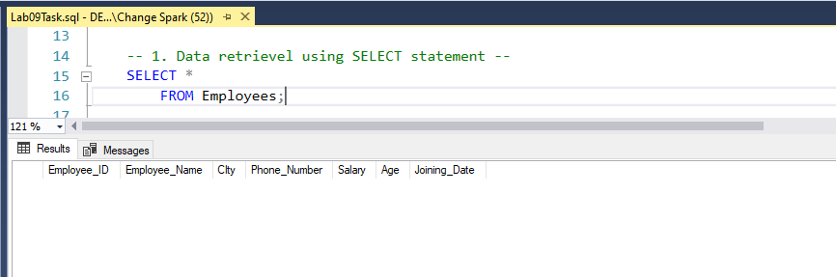
Query:
-- 2. Data insertion using INSERT statement --
INSERT INTO Employees (Employee_ID, Employee_Name, City, Phone_Number, Salary, Age, Joining_Date)
VALUES
(101, 'Ali', 'Islamabad', 0323423, 90000, 27, '2024-03-02'),
(102, 'Sameer', 'Lahore', 0342322, 85000, 26, '2023-07-02'),
(103, 'Khan', 'Karachi', 0342331, 79000, 25, '2023-05-02'),
(104, 'Saad', 'Peshawar', 0334320, 95000, 29, '2022-01-02');

PRINT 'Records successfully inserted';

YE QUERY KHUD CHANGE KR LO, YE NAMES or phir yaha upload kr

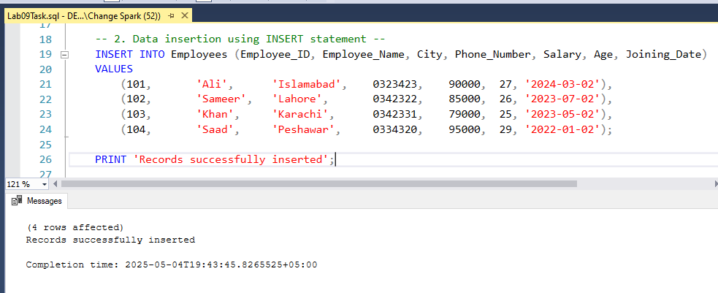

Inserting data only
Iss ko dekh lo khud change kr lo ye wala, pta nhi jo name waghera use kiye hai, cheating pakra ja sakta hai

